## **Node 2 : YCP.PY.L2.C3.G1.N2 - Deep dive into Widgets**

**Lesson Description**

* In this lesson, we will deep dive into Widgets and learn to do things with their usage
* Student Link: <https://repl.it/@coding2/YCPPYL2C3G1Node2>
* **Task 1: Changing colours**
* *Click Run and observe the output?*from tkinter import *  
     
  window = Tk()  
     
  window.title("Hello world")  
     
  btn=Button(window,text="Click me!")  
  btn.grid(column=1, row=0)  
     
  lbl = Label(window, text="Hello,Let's Code")  
  lbl.grid(column=2, row=0)  
     
  window.geometry('400x400')  
  window.mainloop()
* *Can you see the required output?* [Wait for the student to answer]
* *Now let’s try and change the colour of the button.*
* *Inorder to change the colour of the button we need to add two properties*
  + *FG Stands for Foreground Colour*
  + *BG stands for Background colour*
* *Now let’s try adding it to the button, Add fg=”*Colour name*” and bg=”*Colour name* inside the the brackets of the button widget.Separate them by ,*btn = Button(window, text="Click Me", bg="orange", fg="red")
* *Click on run to see the output*
* *Can you now add a colour to the label the same way?*

**Task 1: Solution**

from tkinter import *

window = Tk()

window.title("Hello world")

btn=Button(window,text="Click me!",bg="orange",fg="white")

btn.grid(column=1, row=0)

lbl = Label(window, text="Hello,Let's Code",bg="orange",fg="red")

lbl.grid(column=2, row=0)

window.geometry('400x400')

window.mainloop()

**Output Displayed:**

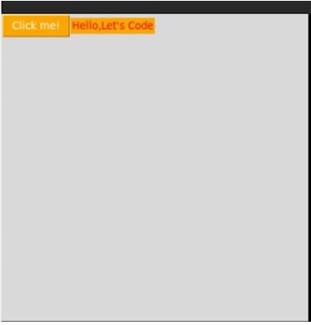

**Task 2**

**Task 2: Functioning it!**

* *Let’s try to put that button to some use*
* *Inorder for the button to perform some action, we need to trigger it with some function.*
* *We will have to assign it to a function and call the function everytime we click on the button*
* *In order to add a button to the function, we need to add it with “command=functionname”*btn=Button(window, text="Click me!", bg="orange",command=clicked)
* *Here ‘clicked’ is the function that we will be defining in a while.*
* *Can you try it on your own?*[Give some time for the learners to try the code on their own. Do not run it now]
* *Now let’s define a function to modify the text in the label “Hello, Let's Code” to “Coding is fun”*
* *In order to do that we will use the “configure” inside the method*
* *“Configure is used to modify the text label.*def clicked():  
   lbl.configure(text="Button was clicked !!")
* *Remember to define this function before the button widget.*
* *Here ‘lbl’ is the label that has the text and ‘configure’ is the function that will change the text to “Button was clicked”*
* *Now let’s run the program and click on the button. Does it work?*

**Task 2: Solution**

from tkinter import *

window = Tk()

window.title("Hello world")

def clicked():

lbl.configure(text="Button was clicked !!")

btn = Button(window, text="Click me!", bg="orange", command=clicked)

btn.grid(column=1, row=0)

lbl = Label(window, text="Hello,Let's Code", bg="orange", fg="red")

lbl.grid(column=2, row=0)

window.geometry('400x400')

window.mainloop()

**Output Displayed:**

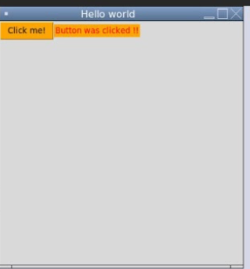

**Task 3**

**Task 3: Quick Challenge**

* *Now here’s a nice little task for you*
* *You need to change the colour of the background on click and add one more button to the window that will bring the text back to its original form*
* *Hint: Add one more button to the window. Define it using ‘btn2’ and create a function called ‘declick’*
* *Hint 2: Use the same configure to change the bg the same way as text. Separated by,*
* *Hint 3: Click should change the bg to white*
* *Hint 4: Declick should change it back to orange*[Give the learner an ample amount of time to solve this challenge. Help them if they are struck. Ask them to execute the code after they are ready]

**Task 3: Solution**

from tkinter import *

window = Tk()

window.title("Hello world")

def clicked():

lbl.configure(text="Button was clicked !!", bg="white")

btn = Button(window, text="Click me!", bg="orange", command=clicked)

btn.grid(column=1, row=0)

def declick():

lbl.configure(bg="orange")

btn2=Button(window, text="Click me 2", bg="white",command=declick)

btn2.grid(column=3,row=0)

lbl = Label(window, text="Hello,Let's Code", bg="orange", fg="red")

lbl.grid(column=2, row=0)

window.geometry('400x400')

window.mainloop()

**Output Display:**

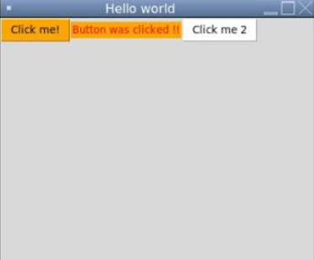

**In the end**

* *You learnt to use functions with buttons and change labels.*

**Solution**

* Solution link: [https://repl.it/@CuemathCoding1/YCPPYT2C3G1Node2-Solutions#main.py  
  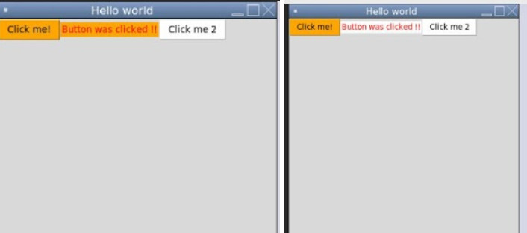](https://repl.it/@CuemathCoding1/YCPPYT2C3G1Node2-Solutions#main.py)